For first time setup of handbrake, once you've installed it, run it and do the following steps:
You must first choose a video to open, it can be any video but we are unable to make the necessary settings changes without one.
Once you have selected a video you will see this screen (with a preview of your video that will be different to the one shown here).
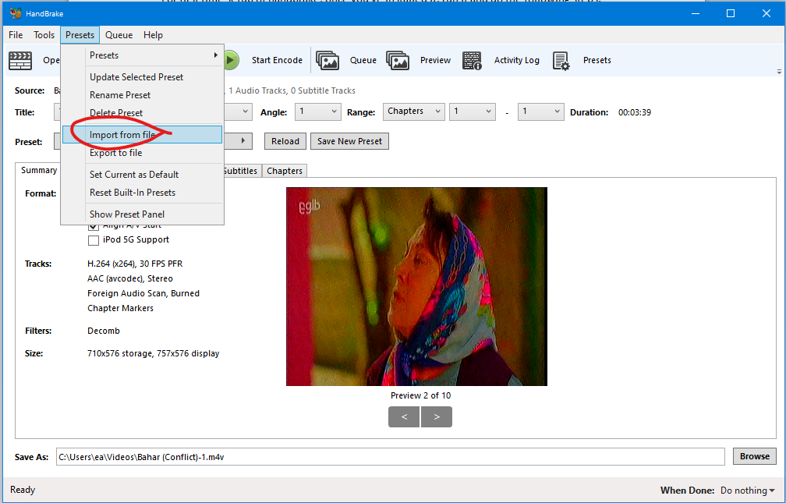

IAMtech has provided a video encoding preset that is suitable for use on IAM networks and maintains good enough quality to view on a TV or video projector or computer. We have optimised it for creating the smallest possible video file while maintaining viewing quality. It might not have high enough quality if you are using the video to teach detailed needlework (sewing) or weaving or other videos that require very high detail in the images. If you need a higher quality preset for a purpose like this, please contact IAMtech for help to create one.
You need to choose presets as shown, then choose import from file as shown and choose "Handbrake preset 640x360 25fps 96kbps 44.1kHz stereo.json" as provided by IAMtech.
Next you need to select the new preset as shown here:
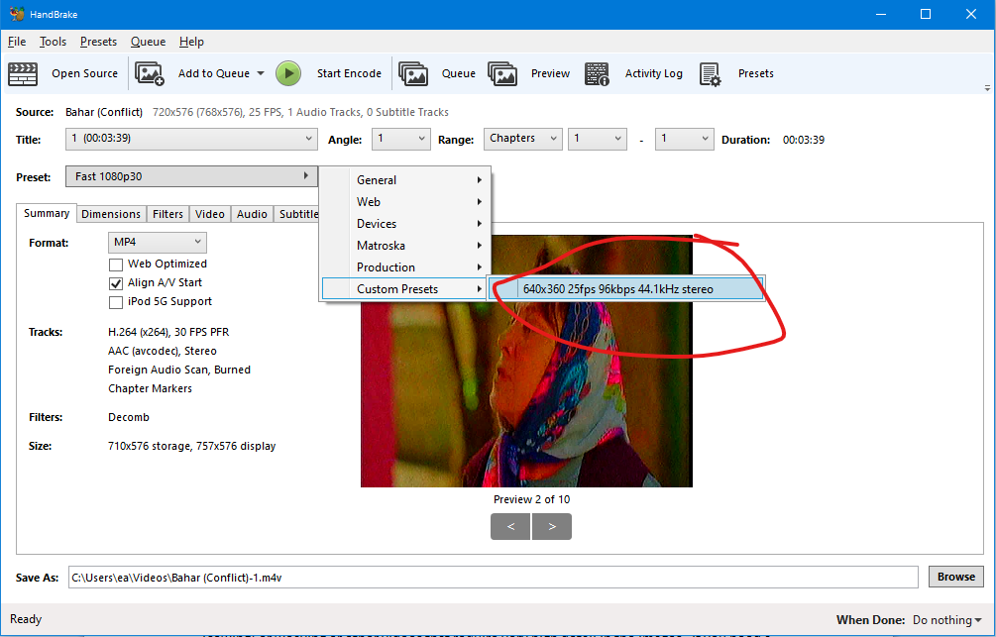
Now from the presets menu, choose set current as default, as shown here.
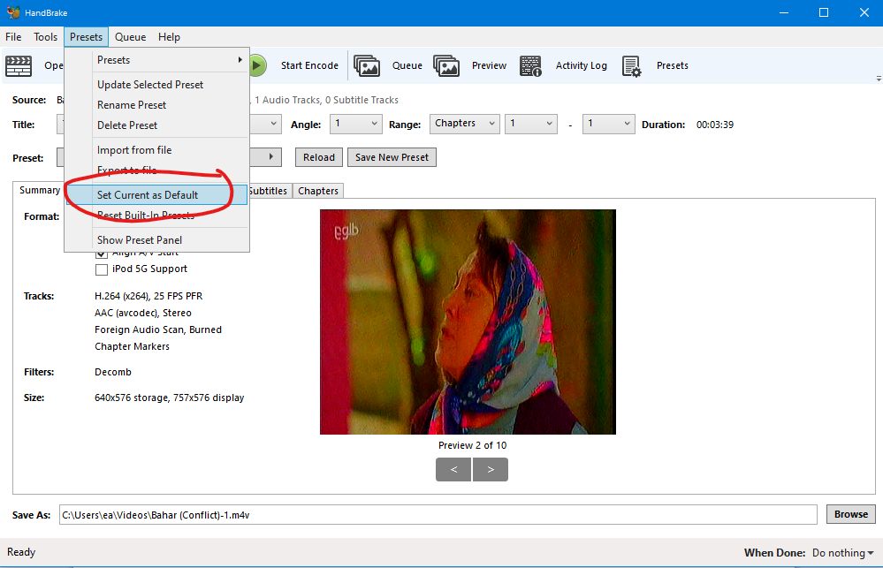
Now you can select videos you want to convert and add them to the queue and then start encoding. If you only need to encode one video then you don't need to add it to the queue before you press start encode.

